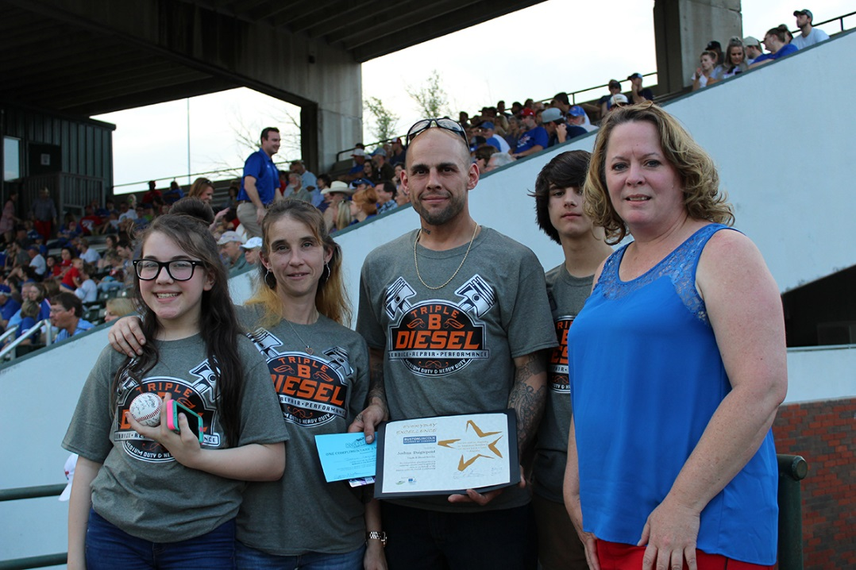

On April 21, 2017 the first #EverydayExcellence award was presented to Joshua Daigrepont, owner of Triple B Diesel Service, located at 1721 Industrial Drive in Ruston. A woman in Miami, Florida wrote in to say that her 80 year old parents broke down in Ruston while traveling in their motor home. Not only did Joshua assist them after business hours, he offered them a hook-up at his shop and let them stay there until the parts were located and the repairs were made.
The award was presented at the LA Tech vs UAB Friday evening game during Ruston Community Weekend. Joshua threw the first pitch and received a certificate, 3 month pass to Rocketfast Car Wash, and a $25 gift card from YEA! (Young Entrepreneurs Academy).

