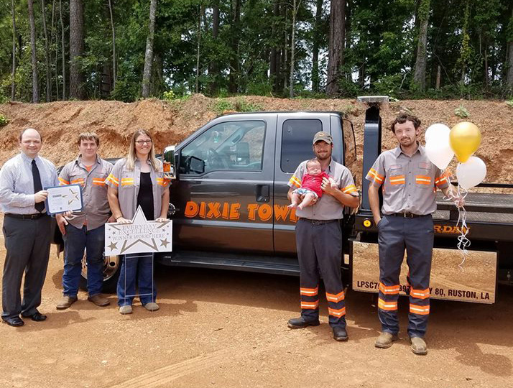
Congratulations to Dixie Towing Service for being selected as the June Everyday Excellence winner. Located at 3976 Hwy 80 in Ruston, Dixie Towing is known as a caring group of individuals who have very big hearts. Dixie Towing was nominated for the award by Daniel Norred, who said “Dixie Towing out of Ruston LA just made a huge impact for not only myself but to others in the area. They are very humble and never boast about the kind things that they do.”
This month’s winner received a $25 gift certificate from The Cleaners of Ruston, a 3-month pass to Rocketfast Car Wash, and a gift certificate for an adult gym class at Paradigm Gym. They also received a certificate of excellence to place in their office and a yard sign to place in front of their business.
The Ruston-Lincoln Chamber of Commerce would like to encourage everyone to nominate people in Lincoln Parish who are especially kind. It may be a clerk at a fast food restaurant or retail store or it could be someone who was overly pleasant on the phone. Nominations can be made on our Facebook page (@RustonChamber) or they can be emailed to Ivana Flowers, iflowers@rustonlincoln.org.
Shown in picture left to right are Earl Smith, Matthew Driskill, Misty and David Smith-Owners, baby Trip Smith and Thomas Smith. #EverydayExcellence

