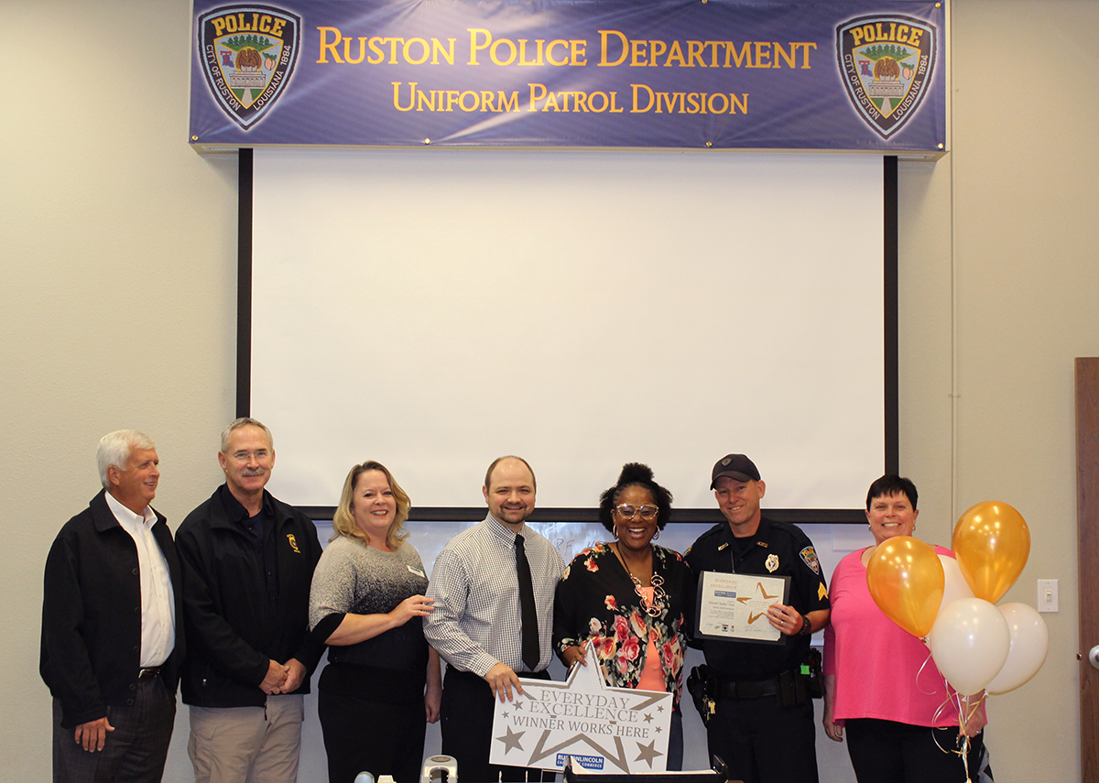

It began with a Facebook post from Reshon Ford that went viral. Ford, a three-time cancer survivor, has her car elaborately decorated in pink, with balloons, feather boas and posters. The vehicle is what caught Sgt. Faile’s attention and he pulled her over to ask if she was a cancer survivor. Having a daughter who was also a survivor, Faile told Ford, “I just want to hug your neck” after hearing her story and seeing her enthusiasm. “Cancer survivors and those battling cancer are the real heroes,” said Faile, “they fight the hardest battles.”

Sgt. Faile was aware of the Facebook post, but did not expect the post to go viral and receive as much attention as it did. “I don’t do this for the recognition” said Faile, “people need to be kind to one another, and doing a little something to brighten someone else’s day can go a long way”.

Sgt. “Bubba” Faile was awarded a certificate of achievement, a $25 gift certificate from La Bella Salon, 3 months pass from Rocketfast Car Wash, a free night’s stay at Best Western PLUS Ruston, a gift from Ruston Apothecare, and an adult class from Paradigm Gym.

#EverydayExcellence is an initiative that the Ruston-Lincoln Chamber of Commerce promotes to recognize and award those who give an excellent effort in their everyday activities in the Ruston-Lincoln community. To nominate someone, simply post on Facebook.com/RustonChamber providing the person’s name and why you chose to nominate him or her. Nominations may also be submitted for businesses within Ruston-Lincoln.

